Professor Zhang, Jun

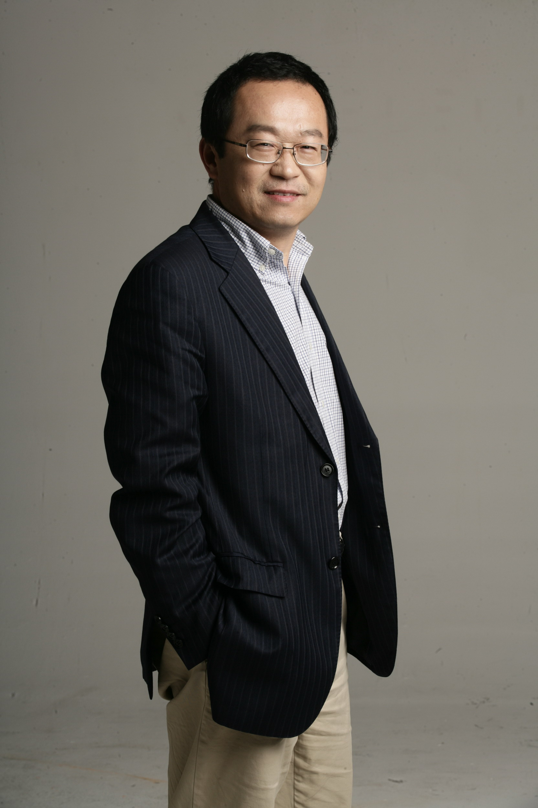

A Chang-Jiang Professor of Economics at Fudan University and Director of the China Center for Economic Studies.

Professor Zhang received his BSc(1985), M.A (1988), and Ph.D (1992) in economics from Fudan University, and was also educated at the London School of Economics and at the University of Sussex as postdoctoral research student in the UK during 1992-1994.

The areas of his teaching and research have been on China’s economic
Transformation and development, with special references to the evolution of property rights and institutional change, capital accumulation, productivity, structural change and economic growth in China.

He has been on the editorial board of the Journal of the Pacific Economy, East Asia
Policy, China Social Sciences Review, China Economics Quarterly, China Economic
Journal, and editor-in-chief of World Economic Papers. He serves as external
examiner for many universities including the Chinese University of Hong
Kong, Peking University, and Tsinghua University, and frequently offers
refereeing service for various journals and for book manuscripts on behalf of various
publishers.

He holds adjunct professorships at many Chinese universities, including East China University of Sciences and Technology, and teaches for EMBA programs at China Europe International Business School (CEIBS), and School of Management and Economics at Shanghai Jiaotong University. Since 1997 he has also held visiting professorships in Washington State University, London School of Economics, SOAS, University of London, University of Aarhus, Tokyo Metropolitan University, Harvard University, Kyungpook National University in Korea, and the World Institute for Development Economics Research of the United Nations University (UNU-WIDER).

Professor Zhang is one of the leading economists in China with many
publications both in Chinese and English. Recent academic contributions have been to The World Economy, China Economic Review, the Journal of Asian Economics, the Journal of the Asia Pacific Economy, the Journal of Chinese Economic and Business Studies, and the East Asian Review. He authored or edited many books including Economic Transition with Chinese Characteristics: Thirty Years of Reform and Opening Up (McGill-Queen University Press, 2008), Transformation of the Chinese Enterprises (Cengage Learning, 2009), and Handbook of the Future of the Chinese Economy (in process, Edward Elgar Publishing Ltd).

Professor Zhang is a respected commentator on China's economic reform who speaks regularly on Chinese TV stations, BBC, CNN, PBS, KBS, and so on. His views on Chinese economy have been widely cited by domestic and international print media, including Wall Street Journal, Financial Times, New York Times, South China Morning Post, etc.

Professor Zhang is also a seasoned speaker who shares with his audience in-depth analysis on Chinese economy. He speaks fluent English and has addressed many organizations, from multinational companies to foreign trade delegations, on topics related to China's economic reform and development.
Professor Zhang has been invited to speak at many high profile events like Wilton Park Conference, St.Gallen Symposium, Mizuhu Forum, Asia Casa, Forbes Forum, Global Financial Forum, The Economist Conference Shanghai Roundtable, Annual meeting of IBM regional leaders, International Financial Services Shanghai Forum, etc.

